Name: Gabriel Wong 143476L Comments :

Wei Heng 143343M

Group:

**Proposal/Report : Assignment 1 (Finite State Machine)**

________________________________________________________________________

**FSM # 1 - Guard (Wei Heng)** States

* When Idle, guard will **Patrol** after 5 seconds.
* If nobody is in sight for 10 seconds during Patrol, 40% chance for guard to **Idle.**
* During Patrol, if thief is spotted with item, **Suspicion** will be triggered.
* When in Suspicion and thief goes near exit, guard will give **Chase**.
* If in Suspicion and nothing happens after 15 seconds, go back to **Patrol**.
* If the guard catches the thief when in Chase, 80% chance to **Arrest** the thief.

Conditions

* When **Idle**, guard will Patrol **after 5 seconds**.
* If **nobody is in sight for 15 seconds** during **Patrol**, **40% chance** for guard to Idle**.**
* During **Patrol**, if **thief is spotted with item**, Suspicion will be triggered.
* When in **Suspicion** and **thief goes near exit**, guard will give Chase.
* If in **Suspicion** and **nothing happens after 10 seconds**, go back to Patrol.
* If the guard **catches the thief** when in **Chase**, **80% chance** to Arrest the thief.

State Transition Diagram

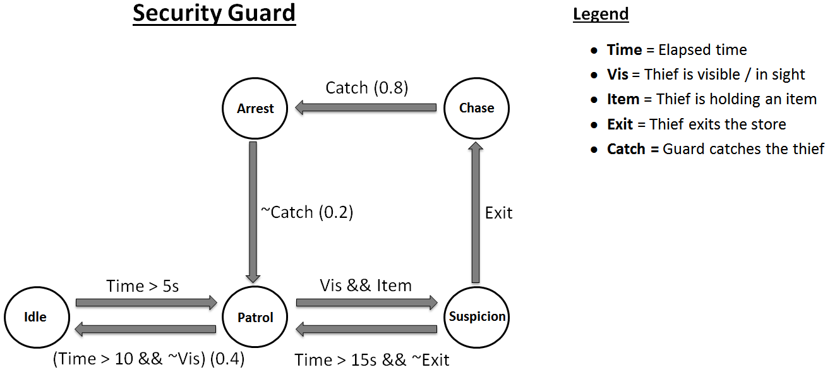

Additional Information

* State explanation:
  + **Idle:** Default state. Guard will stop and rest or wander around aimlessly
  + **Patrol:** Guard will walk around the shop via designated waypoints
  + **Suspicion:** Guard will keep an eye on the thief and follow him from a distance
  + **Chase:** Guard will sprint towards the thief to try and arrest him
  + **Arrest:** Guard attempts to restrain the thief with handcuffs.
* Good-to-have:
  + Have multiple guards. Guards will call for backup during Chase state.
  + A* pathfinding
  + More FSMs, maybe some simple regular shoppers?

**FSM # 2 - Thief** States

Search

* Look for object to steal

Steal

* Goes to the object and takes it

Look

* Looks around before stealing
* Escape(Undetected)
* Walks casually to the exit

Escape(Detected)

* Runs to the exit to escape

Conditions

Search

* The starting state, will look through all the objects to steal and decide between them. 10% chance to select 1

Steal

* This makes the ai pathfind to the object, which then gives it a 60% chance to find something else and goes to the search state, or to look around first. After looking around and Thief doesn’t see anyone he’ll steal it and go to escape state.

Look

* Looks around before stealing
* Escape(Undetected)
* After stealing something and the thief is not detected by security. Will walk to the exit. Once he reach the exit he’ll go back into search state and continue stealing

Escape(Detected)

* After stealing something and the thief detected by security. Will run to the exit and never to return.

State Transition Diagram

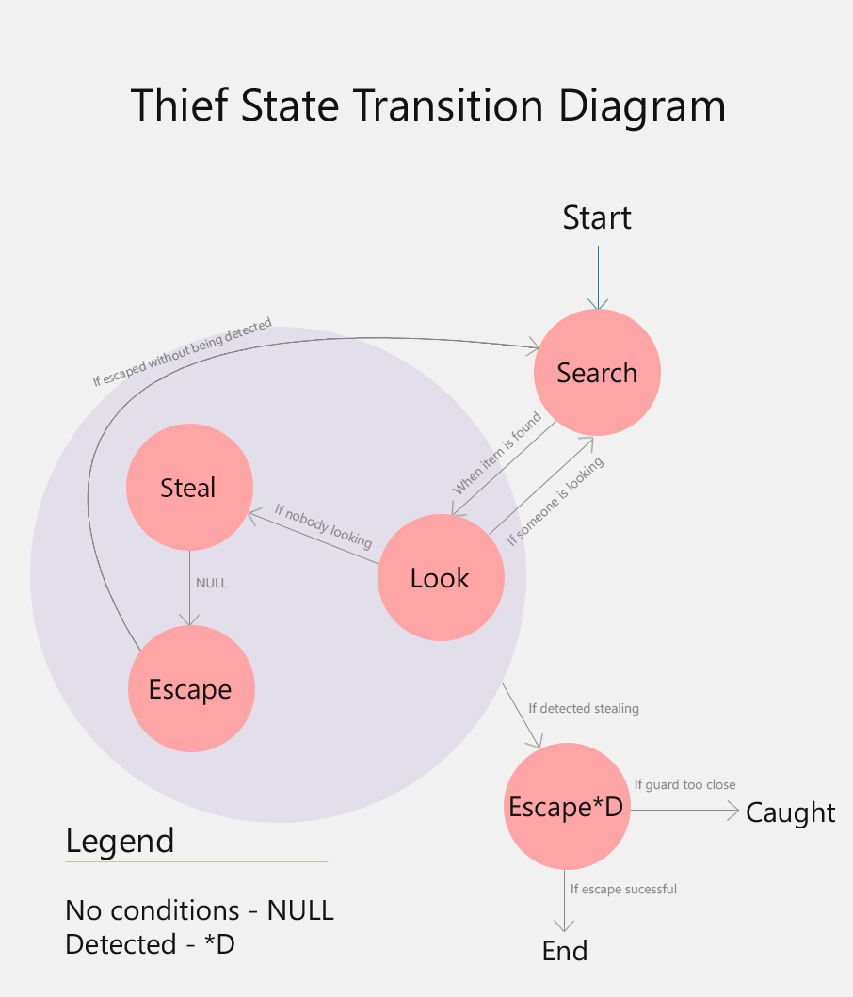

Additional Information

Thief will keep on stealing after escaping until he is detected, in which he’ll never return.

Thief looks by rotating around about 90 degrees to the left, then the right.

After looking, state will return to previous state if there isn’t eye contact.